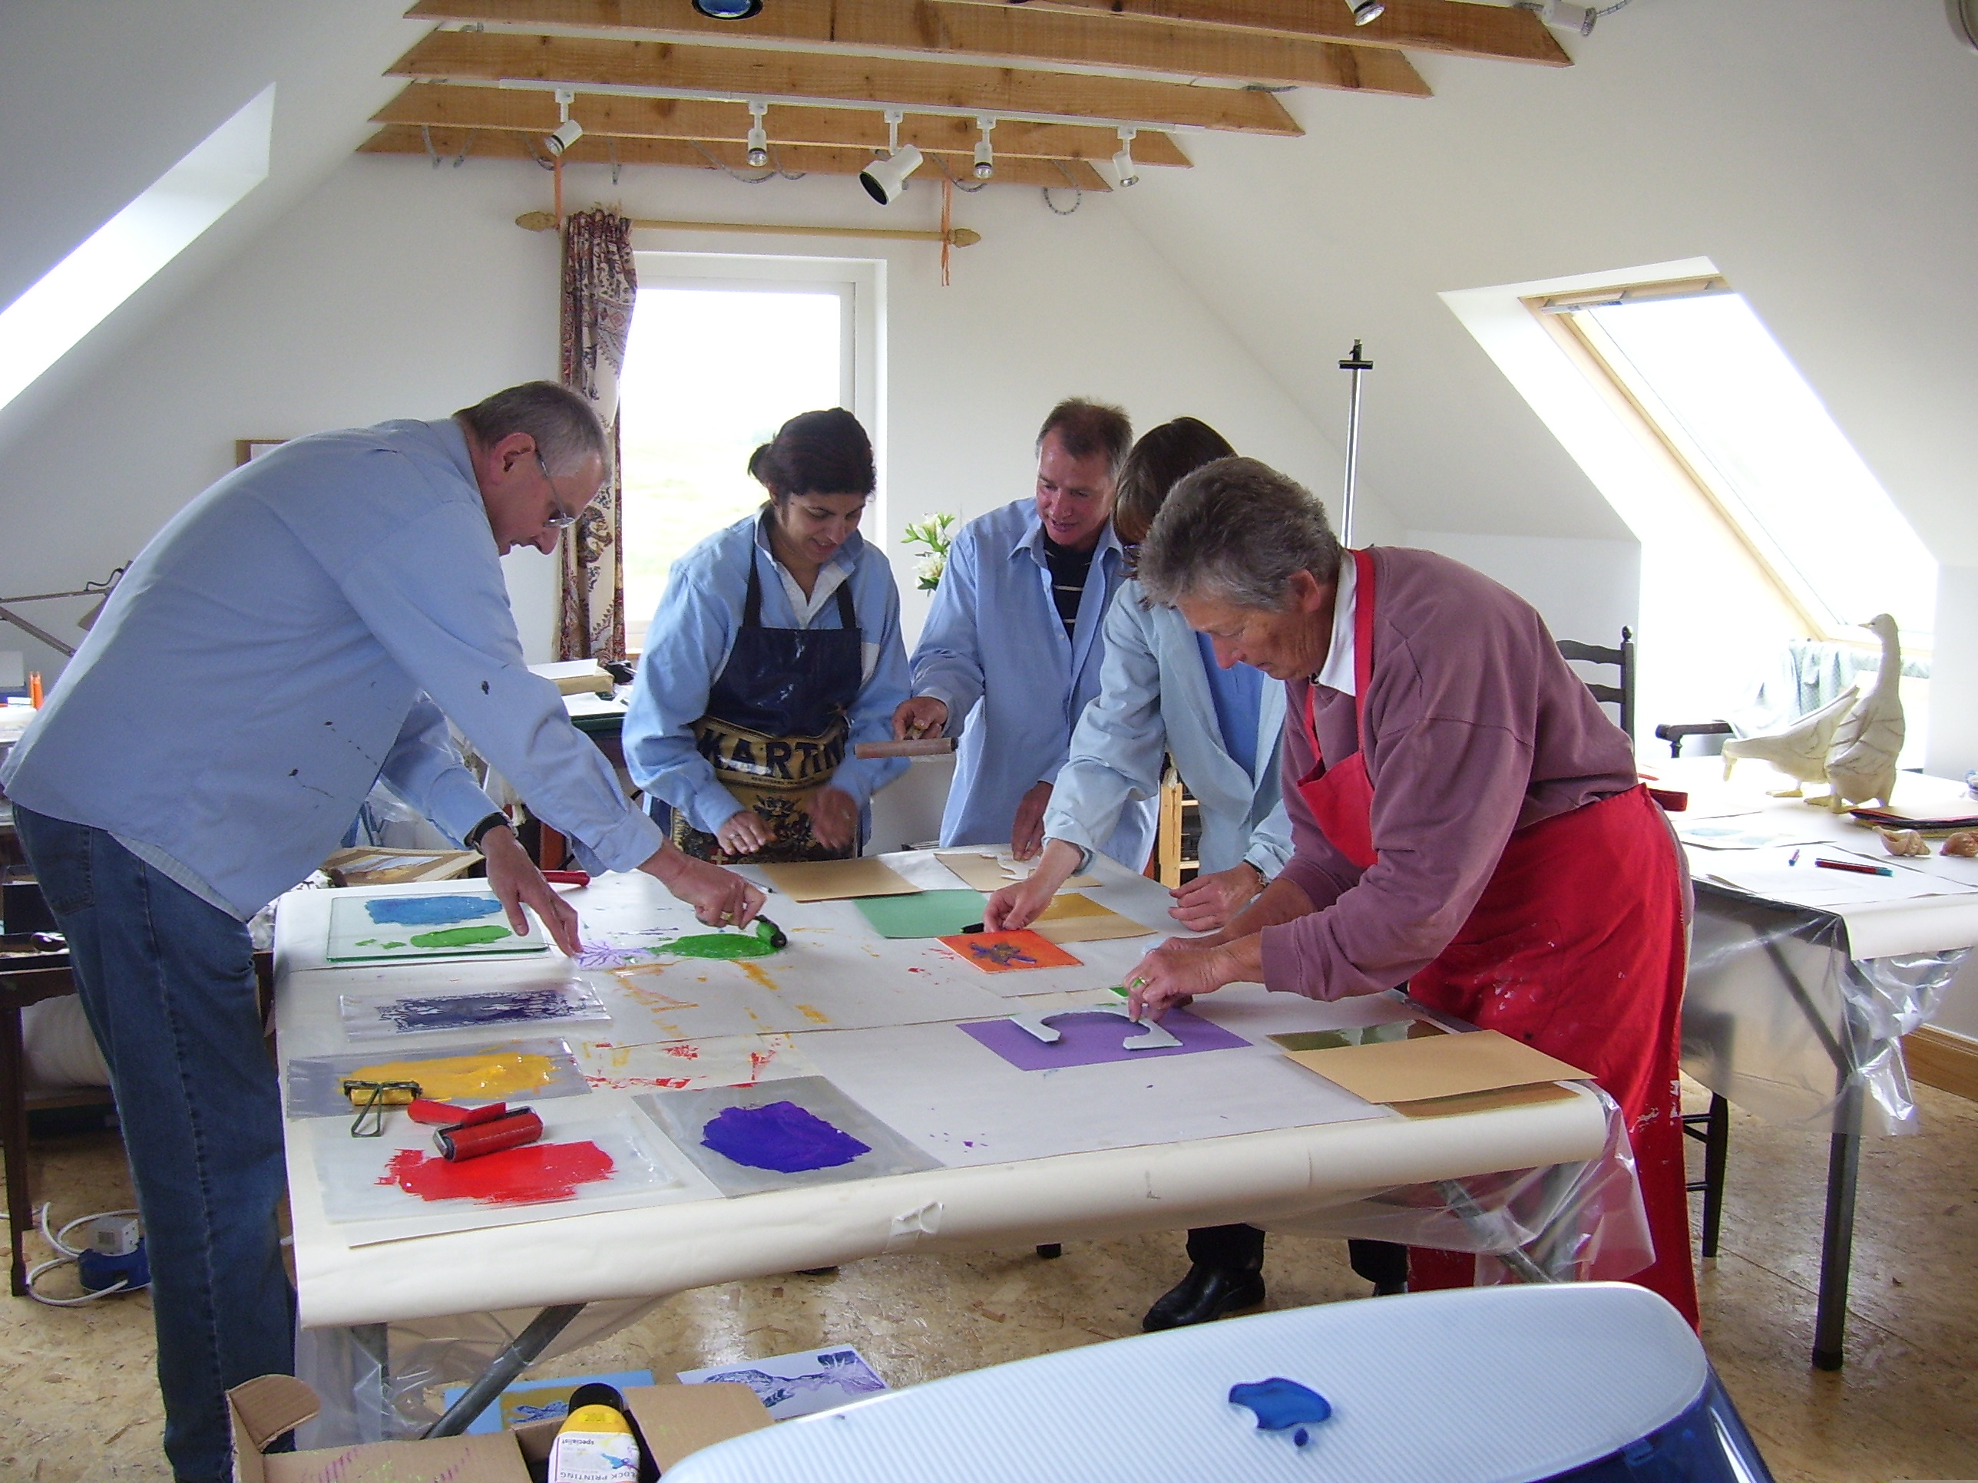

ON HOLIDAY & LOOKING FOR
SOMETHING DIFFERENT TO DO?

….THEN COME TO THE TRAIGH MHOR ART STUDIO
AT 1 BIG SAND, GAIRLOCH!

ONE TO ONE ART TUITION WITH A FULLY QUALIFIED AND EXPERIENCED ART TEACHER

-BRIGHT AND AIRY STUDIO BY THE SEA-

ALL CLASSES TAILORED TO INDIVIDUAL OR GROUP REQUIREMENTS AND ABILITIES

FOR FURTHER INFORMATION:

T: 01445 712200 E: viveca.port@virgin.net

